**MID TERM PROJECT REPORT**

(2020-21)

**Cineamax**



Department of Computer Engineering & Applications

**Institute of Engineering & Technology**

**Team Members**

Anurag Tripathi(181500758)

Himanshu Gautam(181500269)

Abhishek Rai(181500025)

Ashok Singh (181500146)

***Supervised By***

**Vinay Agrawal**

Technical Trainer

**Department of Computer Engineering & Applications**



**Department of computer Engineering and Applications**

**GLA University, Mathura**

**Chaumuha, Mathura – 281406**

**CERTIFICATE**

Certified that this is a bonafide record of the project work titled

**Cinemax**

done by

Anurag Tripathi(181500758)

Himanshu Gautam(181500269)

Abhishek Rai(181500025)

Ashok Singh (181500146)

of V semester Computer Science & Engineering in the year 2019 in partial fulfillment of the requirements for the award of Degree of Bachelor of Technology



in Computer Science & Engineering of GLA University, Mathura.

**Vinay Agrawal**

**Technical Trainer**

(Project Mentor)

**SYNOPSIS**

India is immensely dense with a population of 1.36 billion people among which more than 900 million people don't have sufficient access to the basic needs. Seeing and analyzing such condition of underprivileged people we got this encouragement to contribute to India's development by donating food, clothes, money and other necessities to the underprivileged people. This project is aimed at developing a web application that depicts the contribution of basic needs to underprivileged people. The website consists of a portal of donor, donee and the helper. The donor can donate the necessities such as food, cloth, books, and other miscellaneous things. The donation can be received from any College mess or canteen, marriage party, NGOs, hotels and any common institution. The donor can donate things by logging in the portal and then by sharing their information such address, the donation and timing to receive a donation from the donor. The donee is the poverty-stricken people who are deprived of such basic needs. Donee portal will be logged in by NGOs and other organization working for the welfare of the people, who can receive food from the mentioned address and donate it to the needy people. The Helper portal is for any helping hand like us, who want to come up and make a contribution to the poor people and slum. They will connect the donor and the done in contributing. We will be adding a badge to the respective donor’s portal as they will be contributing needy people.

**ACKNOWLEDGEMENT**

It is our pleasure to be indebted to various people, who directly or indirectly contributed in the development of this work and who influenced our thinking, behavior and acts during the course of study.  
We express our sincere gratitude to **GLA University** for providing us an opportunity to undergo this Project as the part of the curriculum. We are thankful to **Mr. Vinay Agarwal** for his support, cooperation, and motivation provided to us during the training for constant inspiration, presence and blessings.

Lastly, we would like to thank each of the teammates with whom we shared our day-to-day experience and received lots of suggestions that improved our quality of work.  
We perceive as this opportunity as a big milestone in my career development. We will strive to use gained skills and knowledge in the best possible way.



**Names and Signature**

Anurag Tripathi(181500758)

Himanshu Gautam(181500269)

Abhishek Rai(181500025)

Ashok Singh (181500146)

**ABSTRACT**

This project is aimed to create a video streaming platform that will provide world-class videos by the best creators. The idea behind the project is to create an easy to use and ad-free platform where both user and the creator can enjoy. Also, every feature of the site will be free to use lifetime without any charges. The main aim of the project is to reach all age groups from rural areas to urban from having fun content to having some great educational content. Nowadays almost every good streaming platform moving slowly toward paid membership if one doesn’t take membership he is shown up a lot of ads. From this project, we are trying to resolve all these issues. We are trying to create a platform where user can enjoy everything from movies to Education.

**Table of Contents**

**Content**

Approval

Declaration

Acknowledgement

Abstract

Table of content

List of figure

**CHAPTER**

**CHAPTER 1: INTRODUCTION**

1.1 Introduction

1.2 Objectives

1.2.1 Audience target

1.2.2 Future prospects

**CHAPTER 2: PROJECT OVERVIEW**

2.1 Project overview

2.2 System Requirement

2.3 Problem Definition

2.4 Project function

2.5 User characteristic

**CHAPTER 3: FUNCTIONAL REQUIREMENT** 3.1 Login Module

3.2 Signup Module

3.3 Upload video

3.4 subscribe creator

3.5 like/dislike video

3.6 System attributes

**CHAPTER 4: SYSTEM REQUIREMENT**

4.1 Database

4.1.1 front end technologies

4.1.2 back end technologies

4.1.3 Tables

* **FIGURES**

Screenshots

* **TESTING**
* **CONCLUSION**
* **FUTURE SCOPE**
* **REFERENCE**

**Introduction**

**1.1 Introduction**

This project is aimed to create a video streaming platform that will provide world-class videos by the best creators. The idea behind the project is to create an easy to use and ad-free platform where both user and the creator can enjoy. Also, every feature of the site will be free to use lifetime without any charges. The main aim of the project is to reach all age groups from rural areas to urban from having fun content to having some great educational content. Nowadays almost every good streaming platform moving slowly toward paid membership if one doesn’t take membership he is shown up a lot of ads. From this project, we are trying to resolve all these issues. We are trying to create a platform where user can enjoy everything from movies to Education.

**1.2 Objectives**

India is immensely dense with a population of 1.36 billion people and as a result, India has very large web traffic. As we are now slowly moving towards 5g almost every nook of the country will have good and affordable internet service. But not all the people using the internet can afford premium subscriptions of there favourite creators as a result we came up with this project so that we can reach directly to all peoples without

charging them a lot of money and without showing a large number of ads.

**1.2.1 Audience target**

The audience for the project will all the age group all the genders from a child to an old each and every one can enjoy the content.

**1.2.2 Future prospects**

Once the audience reach has increased we can approach more sponsors so that our user as well as our creator both can enjoy best.

**2.1 PROJECT OVERVIEW:**

This project is aimed to create a video streaming platform that will provide world- class videos by the best creators. The idea behind the project is to create an easy to use and ad-free platform where both user and the creator can enjoy. Also, every feature of the site will be free to use lifetime without any charges. The main aim of the project is to reach all age groups from rural areas to urban from having fun content to having some great educational content. Nowadays almost every good streaming platform moving slowly toward paid membership if one doesn’t take membership he is shown up a lot of ads. From this project, we are trying to resolve all these issues. We are trying to create a platform where user can enjoy everything from movies to Education.

**2.2 SYSTEM REQUIREMENT SPECIFICATION**

The software requirement specification is a document that describes the external requirement for any system. The requirement analyst has to identify the requirements by talking to the clients and understanding and responding to their needs. The requirement phase translates the ideas of clients into a formal document. The inputs are gathered from different resources. Input given by the clients may not be consistent. It might change according to the modern requirements.

**2.3 PROBLEM OVERVIEW**

Nowadays almost every good streaming platform moving slowly toward paid membership if one doesn’t take membership he is shown up a lot of ads. From this project, we are trying to resolve all these issues. We are trying to create a platform where user can enjoy everything from movies to Education.

**2.4 PROJECT FUNCTION**

The main aim of the project to show more content and less ad. As data users are increasing each day it’s the perfect time to move toward something that has great future an online streaming platform. User can upload his/her own content and can enjoy content of others.

**2.5 USER CHARACTERSTICS**

The user of this project is supposed to be fairly educated about the usage of the computers. He should understand how to store items and he should have knowledge about various products so that they could be saved. A person who has no knowledge of computers will find it difficult to understand the system. But with a little knowledge it will be very easy to handle the project.

* **Uploader:**

**Description of project:**

Uploader can upload video with a suitable title, description and

And can choose among 3 thumbnails that will be generated randomly form there video. Also uploader can edit or delete there their video after uploading or whenever required.

* **VIEWER:**

**Description of viewer:**

Viewer can watch video, download, like, dislike and subscribe to the creator if he loves there content.

**4. SYSTEM REQUIREMENT**

**3.1 Login Module**

* Input:

Donor enters the login id and password

* Process Definition:

Checks login if and password is valid or not.

* Output:

User is directed to next page where he can watch videos or upload.

**3.2 Signup Module**

* Input:

User enters their details to create new account.

* Process Definition:

Checks whether he entered all the details or not.

* Output:

User is directed to next page where he can view all the available Videos.

**3.3 Upload Video**

* Login

After successful login user can click on upload button to upload there videos.

* Signup

After successful signup user can directly click to the upload button to upload videos.

* Upload button

User can choose and upload videos after clicking on this button.

**3.4 Subscribe creator**

* SUBSCRIBE

Once user logged in/ signed up he/she can subscribe to the creators that he/she likes.

After subscribing users can directly access their creators.

**3.5 likes/dislikes feature**

* **Likes/dislike**

After logging in user can likes and dislike videos also they can access there likes videos directly through liked videos button.

**2.6 SYSTEM ATTRIBUTES:**

• **Portability:**

The Online Mobile Shopping shall run in any Microsoft Windows environments that contain ASP.net platform and the Microsoft SQL.

• **Reusability:** Our system is reusability system since a segment of source code that can be used again to add new functionalities with slight modification.

• **Testability:** Our system is testability system since it supports different types of testing methods.

• **Other Requirements** There are no other requirements.

**4.1 DATABASE  
 DATABASE DESIGN:** Databases are the storehouses of data used in the software systems. The data is stored in tables inside the database. Several tables are created for the manipulation of the data for the system. Two essential settings for a database are-

•  Primary Key - The field that is unique for all the record occurrences.

•  Foreign Key -the field used to set relation between tables.

Normalization is a technique to avoid redundancy in the tables.

1. **4.2 SYSTEM TOOLS**

The various system tools that have been used in developing both the front end and the back end of the project are being discussed here.

**3.3.1.FRONT END:**

HTML, CSS, JAVASCRIPT, BOOTSTRAP are utilized to implement the frontend.

•  HTML (Hyper Text Markup Language)  
HTML is a syntax used to format a text document on the

•  CSS (Cascading Style Sheets)  
CSS is a style sheet language used for describing the look of a document written in a markup language.

• Bootstrap  
 Bootstrap is a free and open-source CSS framework directed at responsive, mobile-first front-end web development. It contains CSS- and JavaScript- based design templates for typography, forms, buttons, navigation and other interface components.

• Java Script  
 JS is a dynamic computer programming language. It is most commonly used as part of web browsers, whose Implementations allow client-side scripts to interact with the user, control the browser, communicate asynchronously, and alter the document content that is displayed. Java Script is used to create pop- up windows displaying different alerts in the system like “User registered successfully”, “Password do not match” etc.

**4.1.2 BACK END**

The back end is implemented using MySQL which is used to design the databases and PHP which is used to do server side scripting.

•  MySQL  
MySQL is the world's second most widely used open-source relational database management system (RDBMS). The SQL phrase stands for Structured Query Language. An application software called Navicat was used to design the tables in MySQL.

•  PHP(Hypertext Preprocessor)  
PHP is a widely-used open source general-purpose scripting language that is especially suited for web development and can be embedded into HTML.

**4.1.3 TABLES**

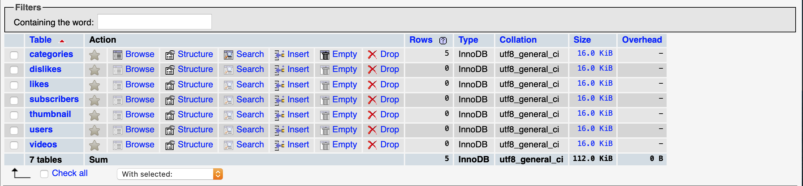 Videotube table

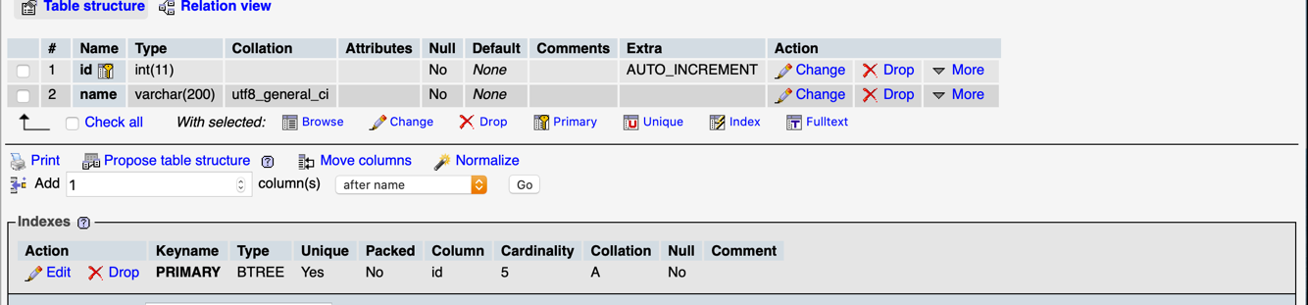

**Categories**

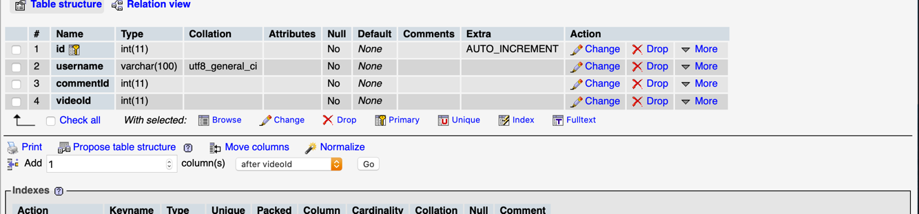

**Dislikes**

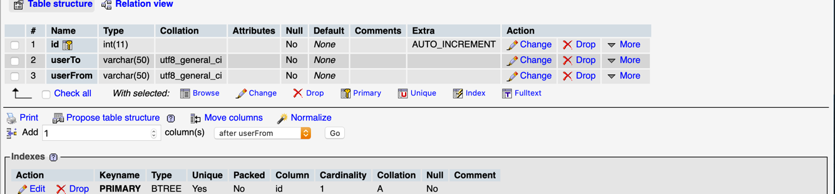

**Subscriber**

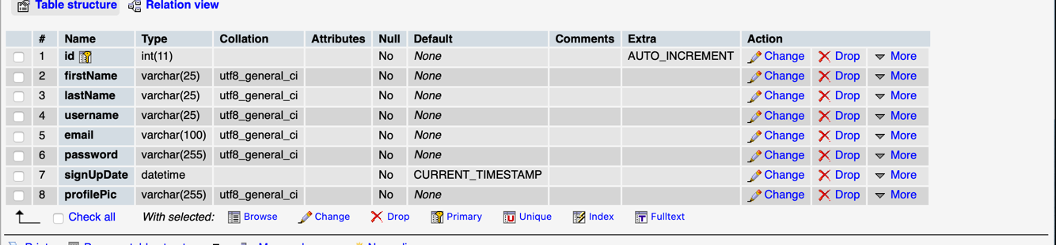

**Users**

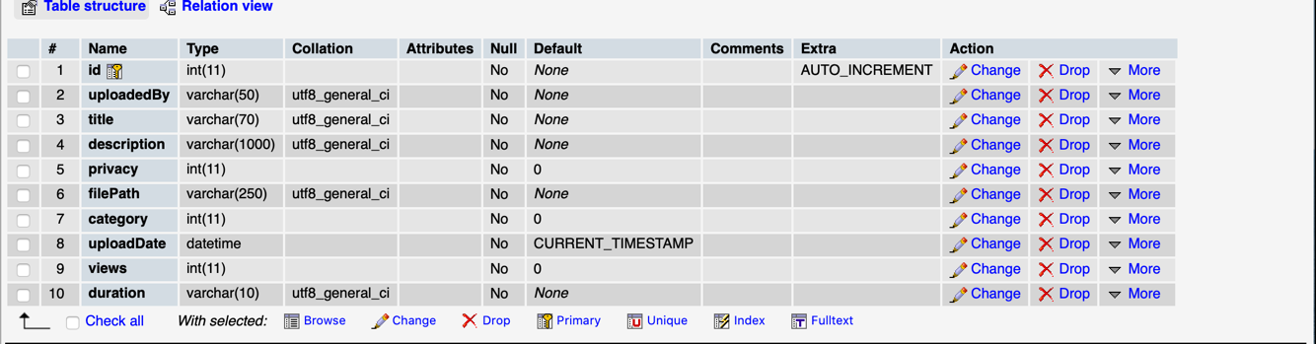

**Videos**

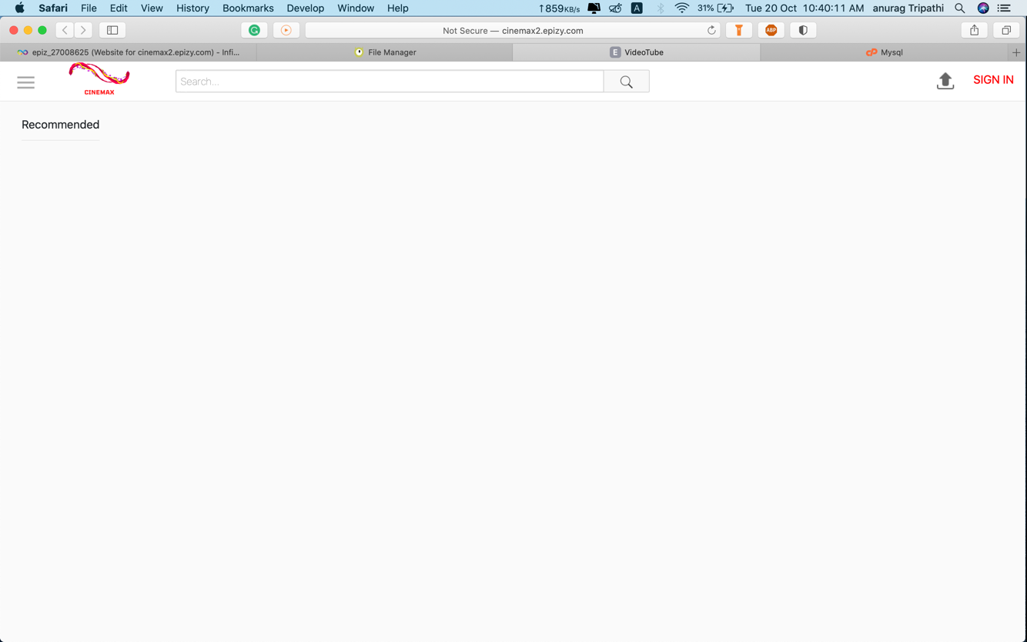

**Home page with recommended section**

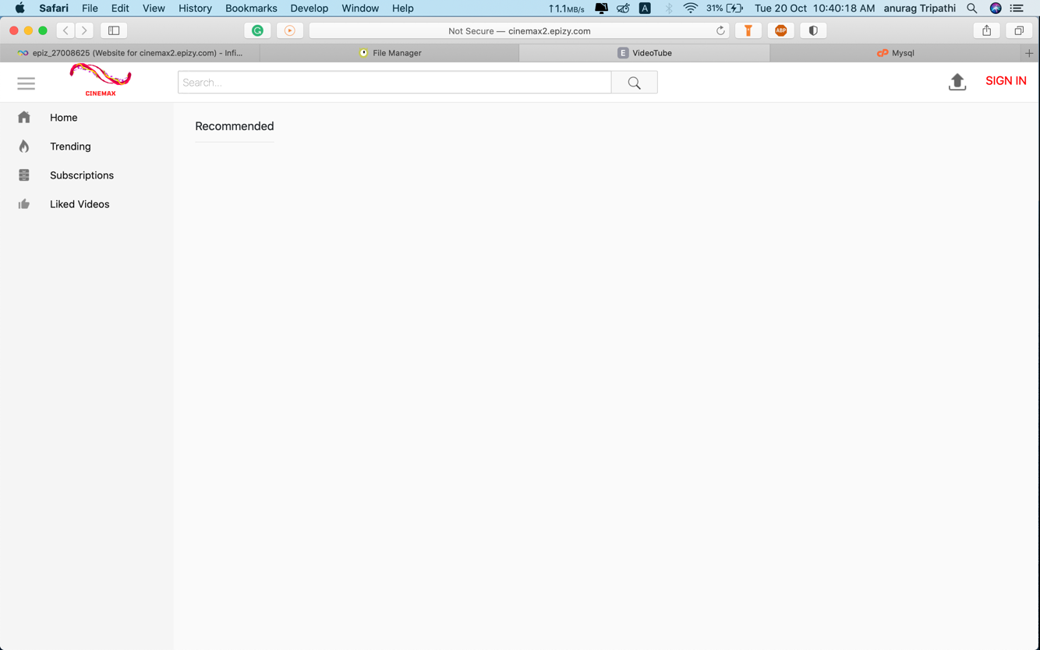

**MENU**

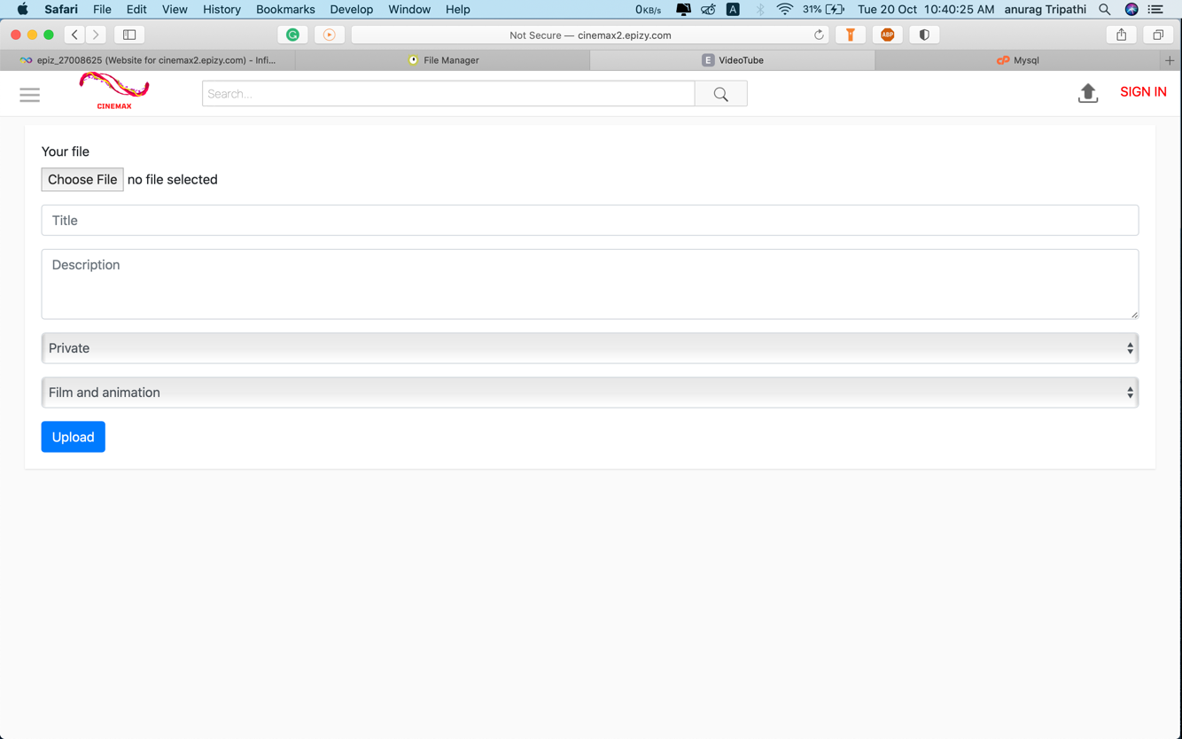

**Upload video section**

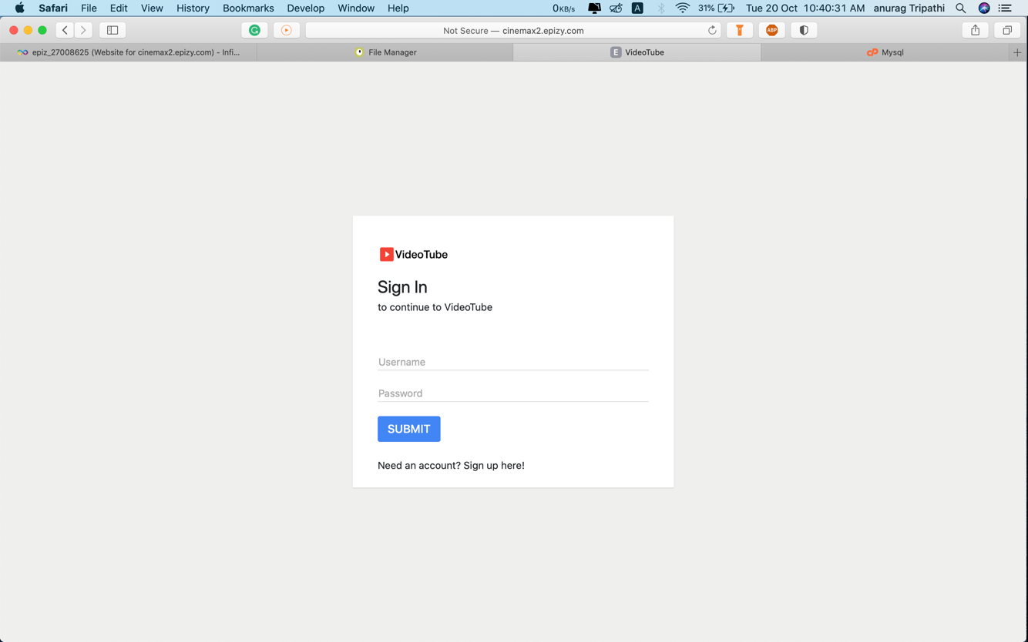

**Sign in page**

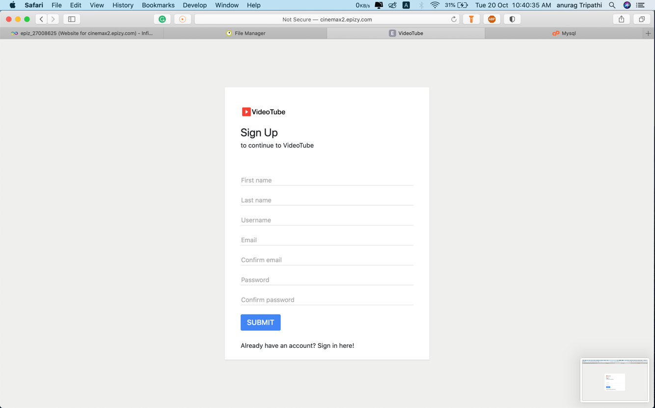

**Signup page**

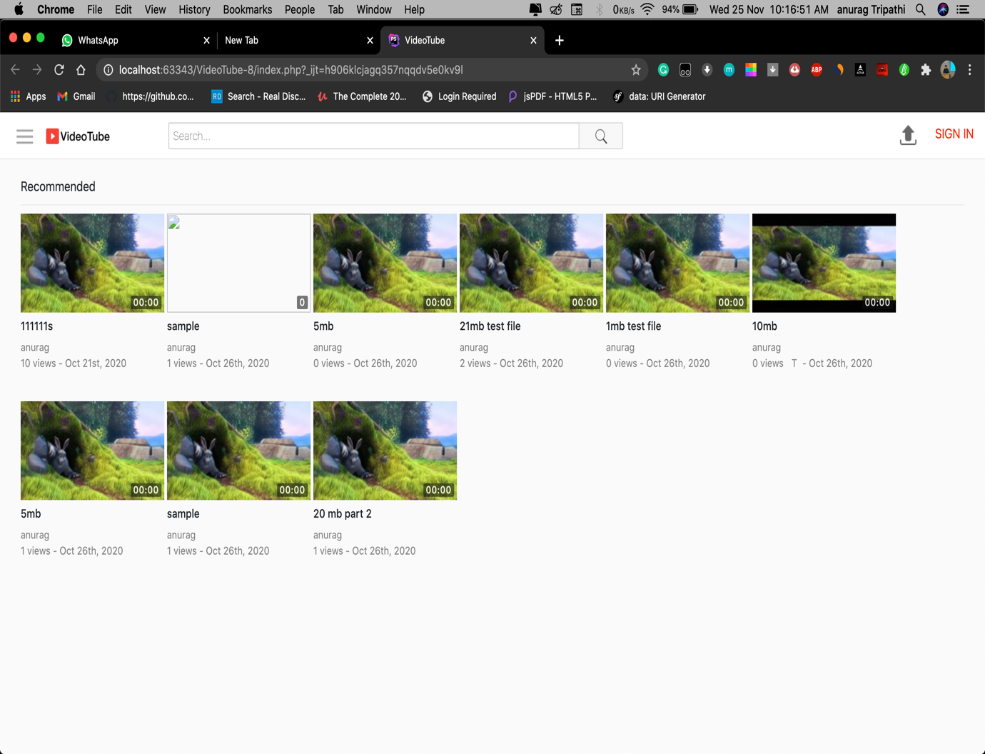

**HOME PAGE**

**HOME PAGE:**

Home page consist of a search bar, menu, signup option and more. Videos with random orders will be shown to user on home page it won’t be personalised it can be any video in any order.

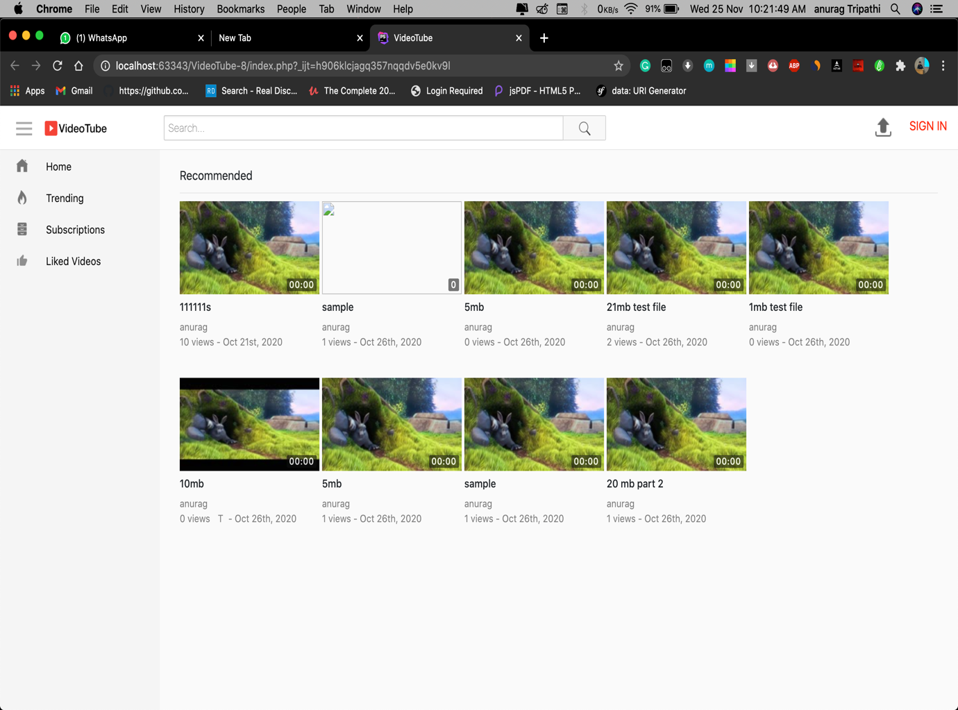

**Left Menu**

**Left menu consist of four options.**

**1)Home**

**2) Trending**

**3) subscription**

**4) Liked videos**

In this subscriptions and liked videos will personalised for each user based on their subscriptions and videos liked.

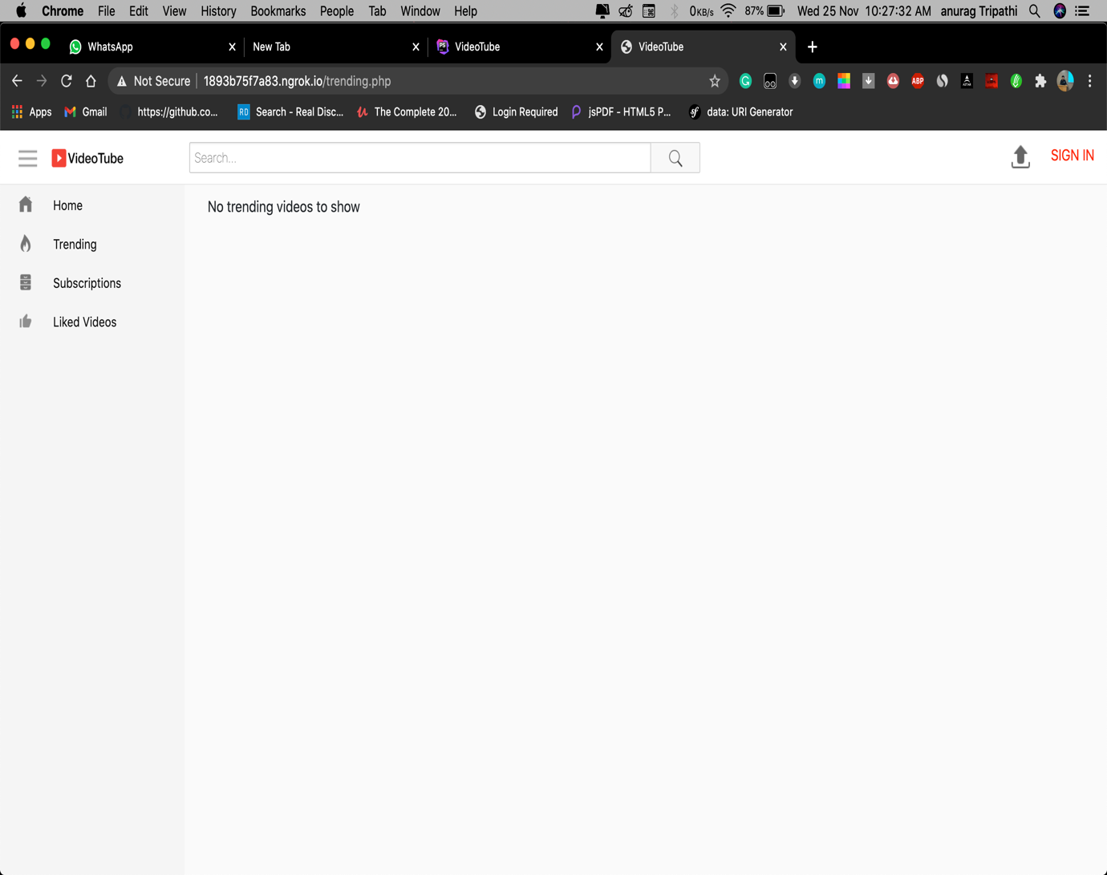

**Trending videos**

**Trending videos :** In this section all the latest uploads will be shown based on how recently they were added. It has designed In such a way that it shows all the latest videos up to 20 videos on one page. After twenty videos there won’t be more videos on trending videos. It will only show maximum twenty videos at once.

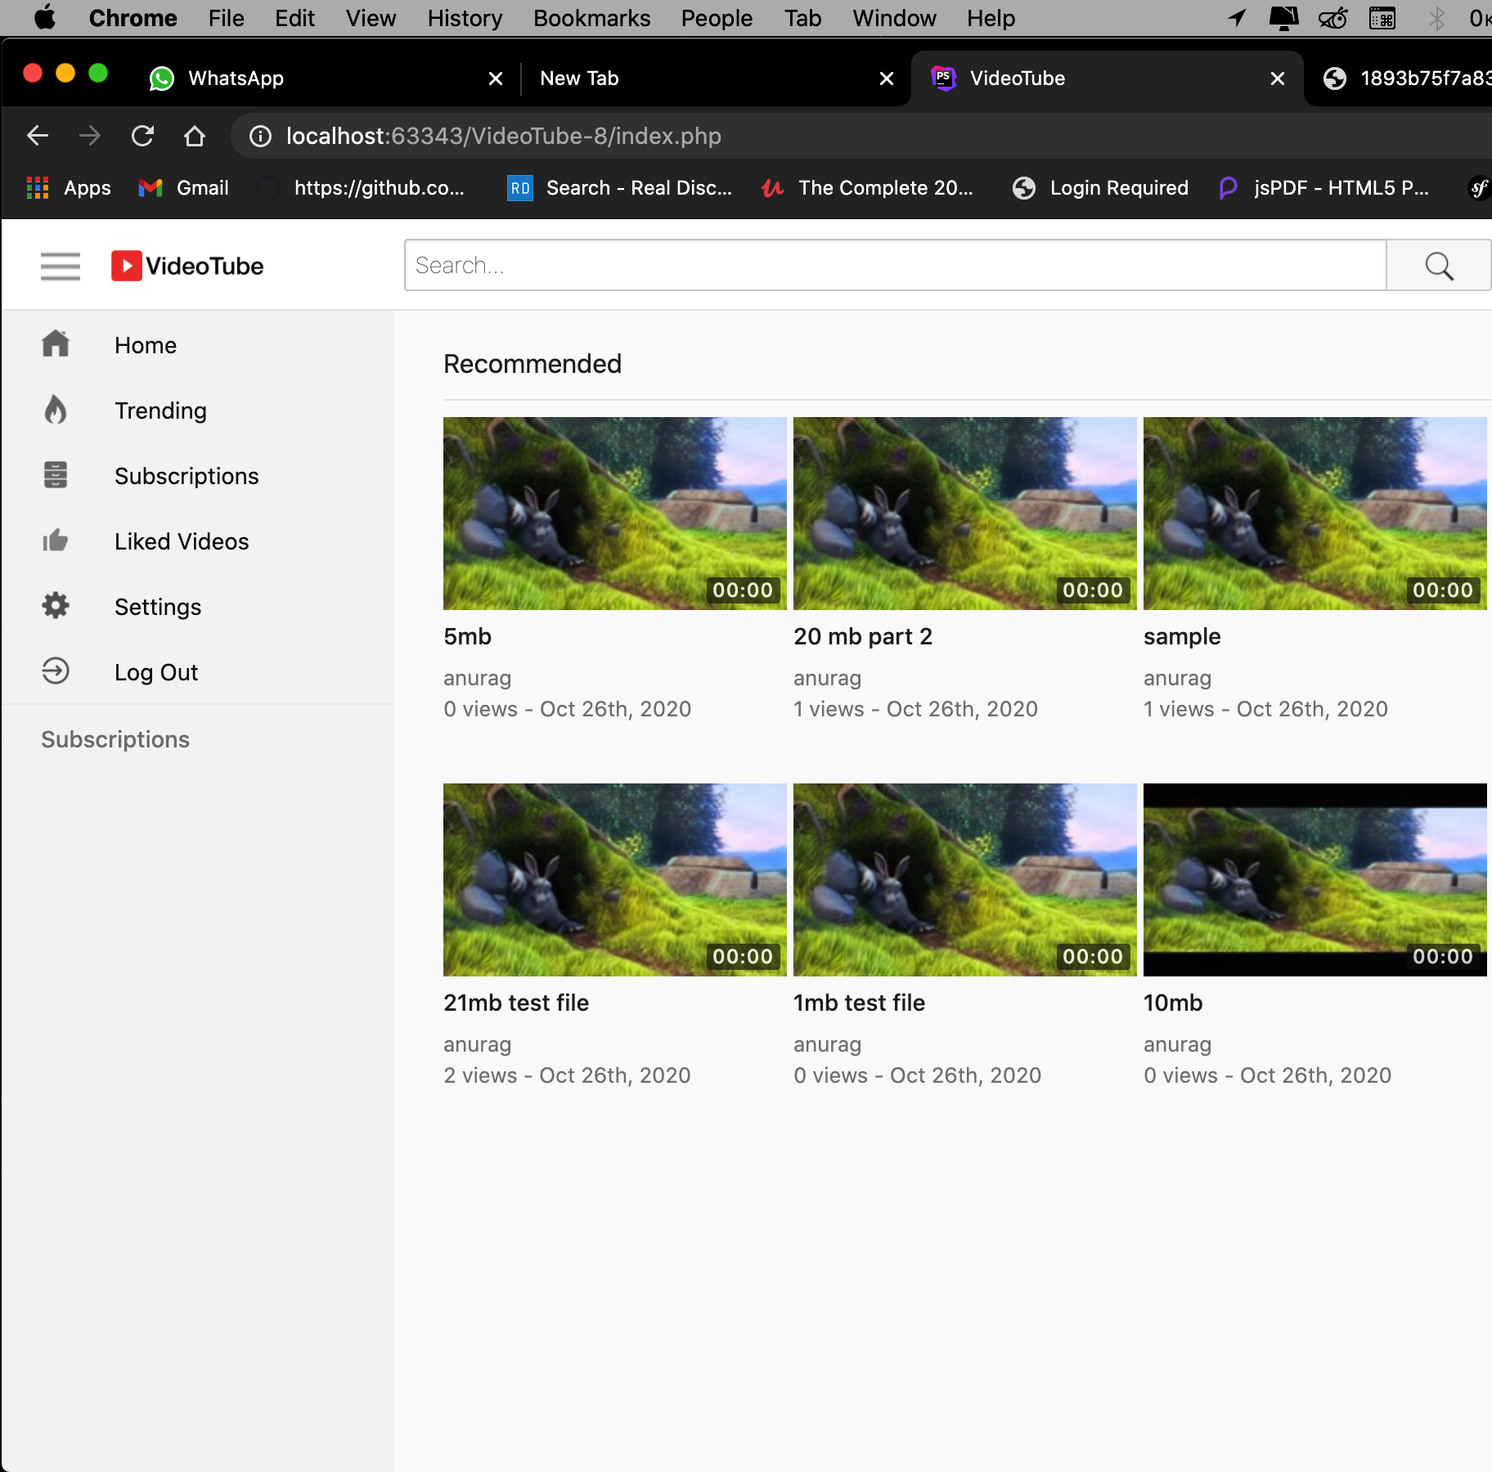

**Left Menu**

For the logged in user there are more options compared to users who aren’t logged in. Log out option will added in the menu if the user has logged in also there will a separate option which will show all there channels which user has subscribed.

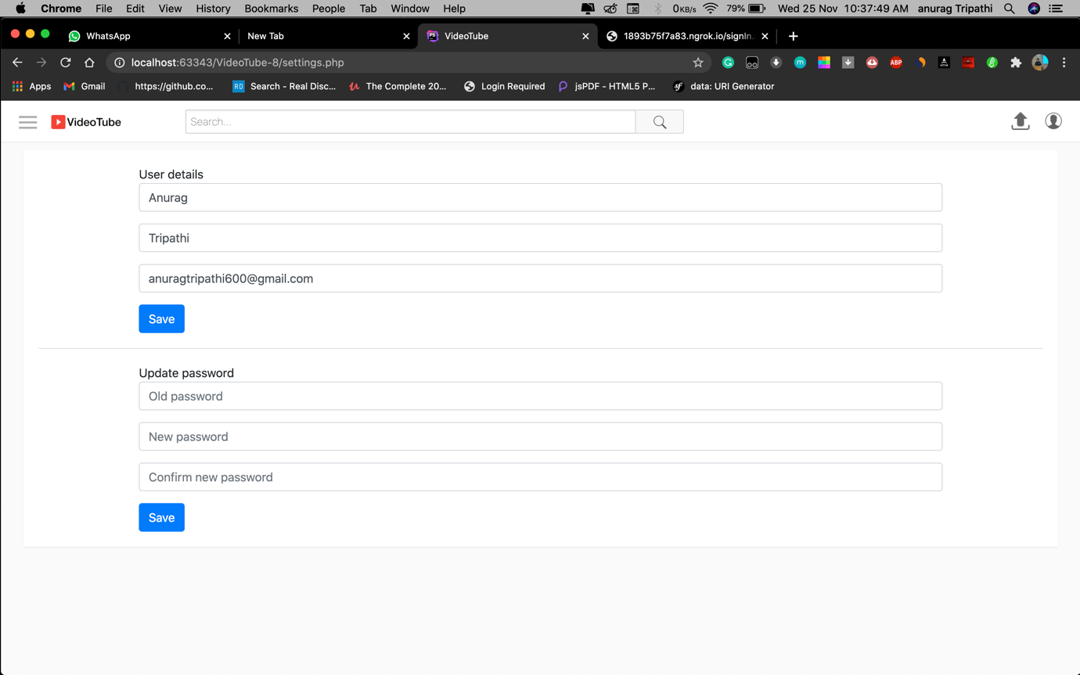

**Setting**

**Setting:**

Once the user has clicked on the setting option from menu he can change his name, username and password. Not only these he can also change his email if needed and the email doesn’t exist in our database. Once user clicks on the save button his information will be updated.

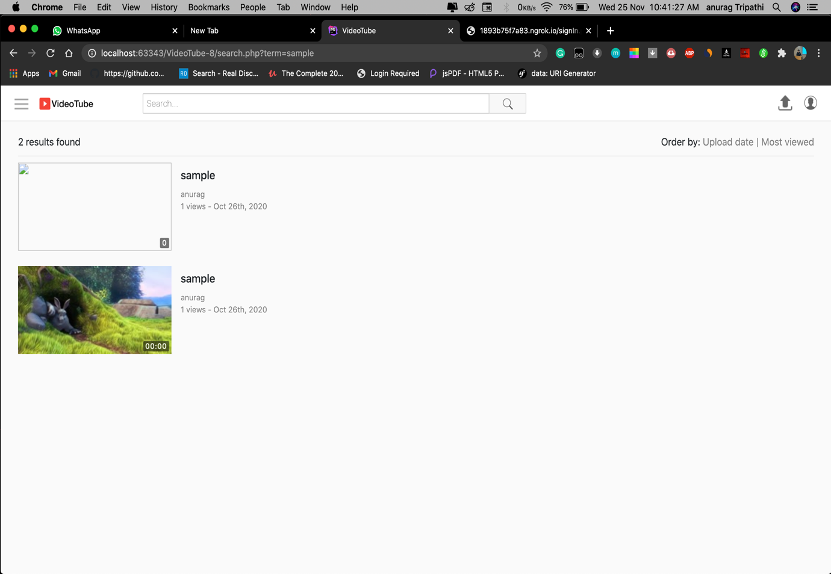

**Search result**

This is how it will output the search result. Even if few spellings match with the title it will show that video as a output. User can also filter there result based on order like sort by upload date or most viewed videos and result will be displayed for the same. It also shows the number of videos that has been found on the search result.

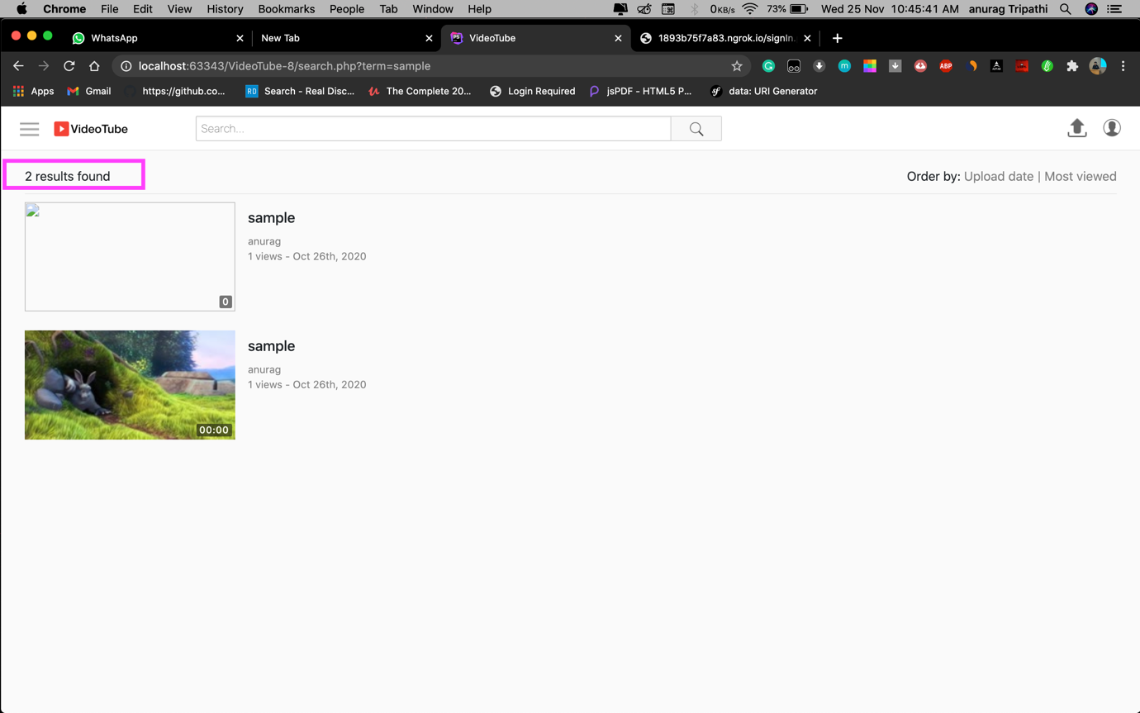

**Number of result found**

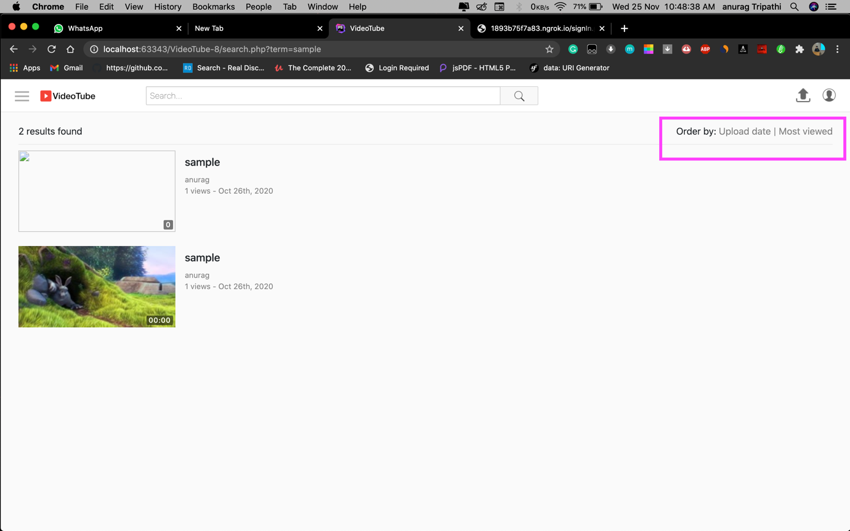

**Filter result by order**

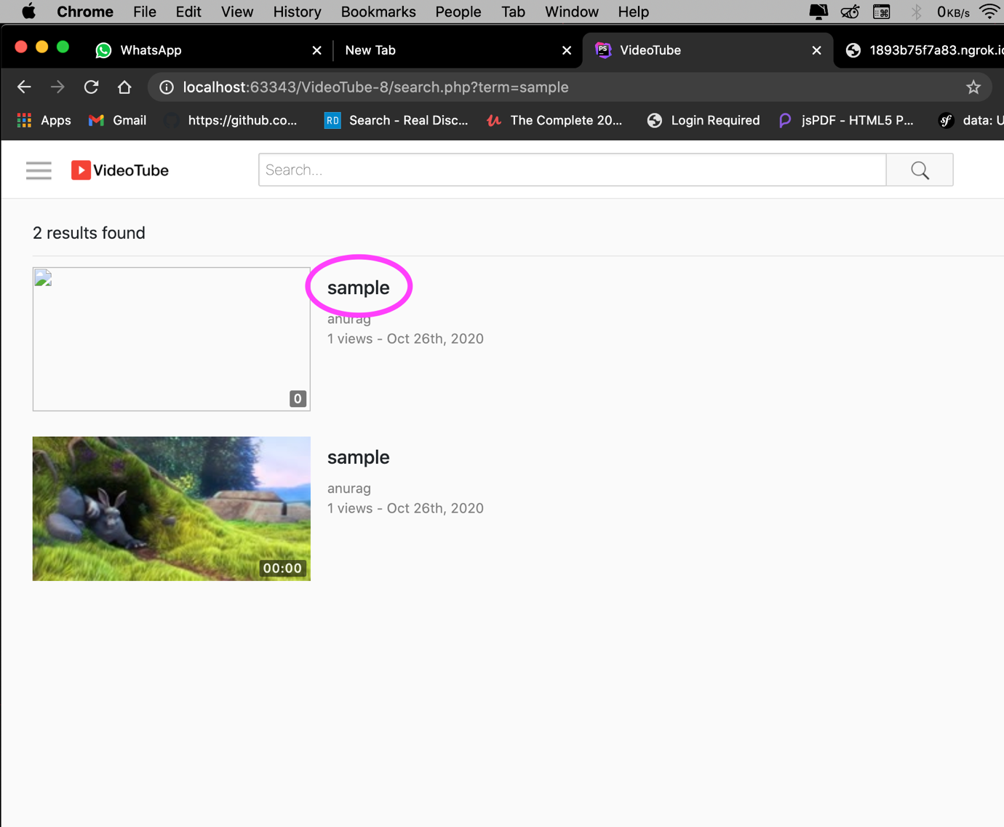

**Title of the video**

Title of the video will shown on the right side of the video as marked on figure.

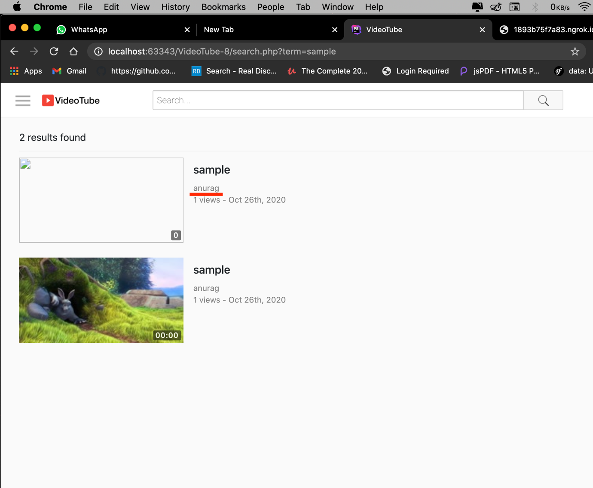

**Creator or the owner of the content.**

Name of the channel or the person will be shown just below the title and it will be unique i.e no two names can be same.

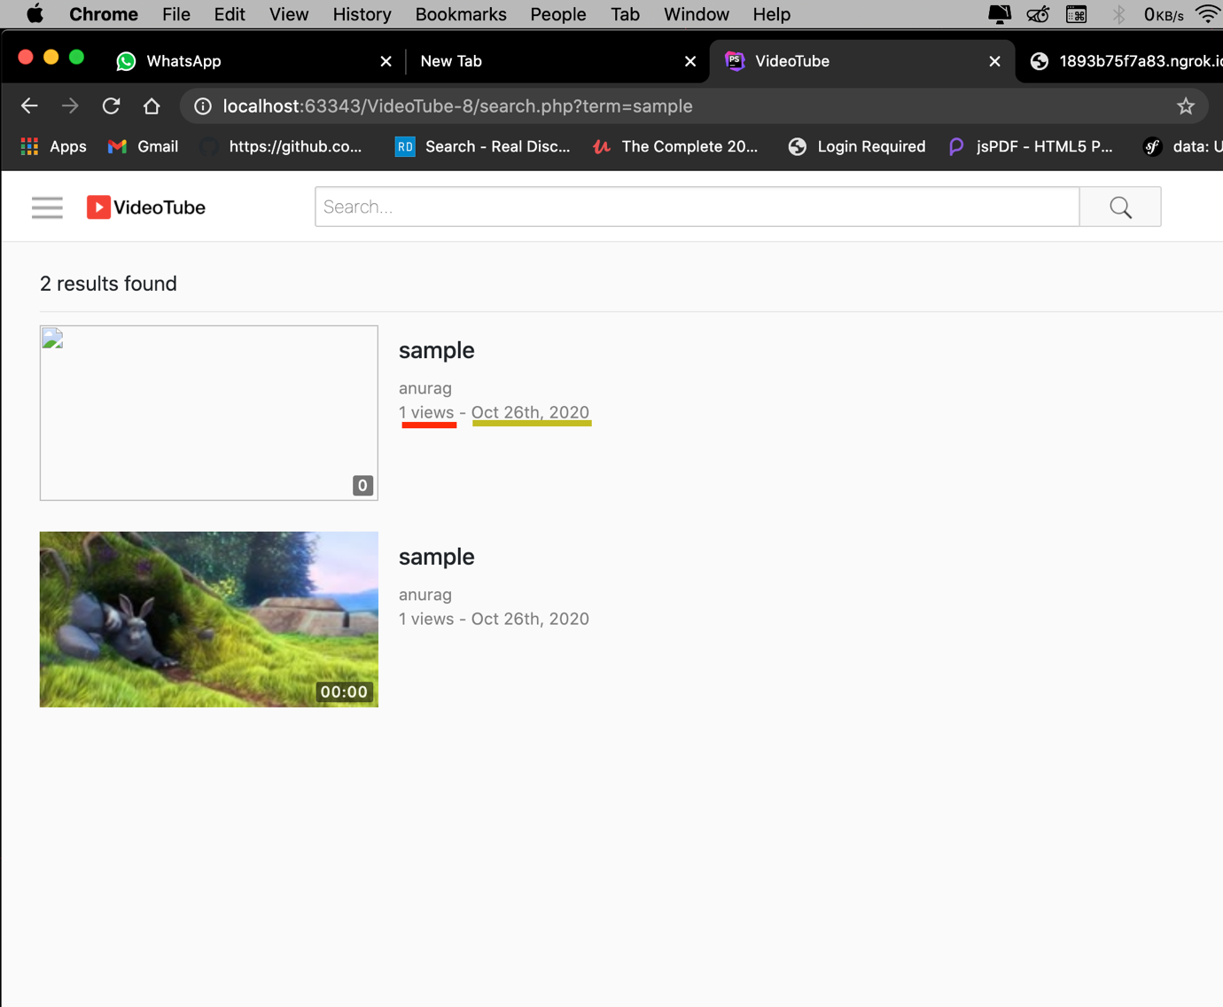

**Number of views and upload date**

Number of views and upload date will shown below the channel name. Views updates real time as user refreshes it.

Format of the date will be month/ date/ year similarly.

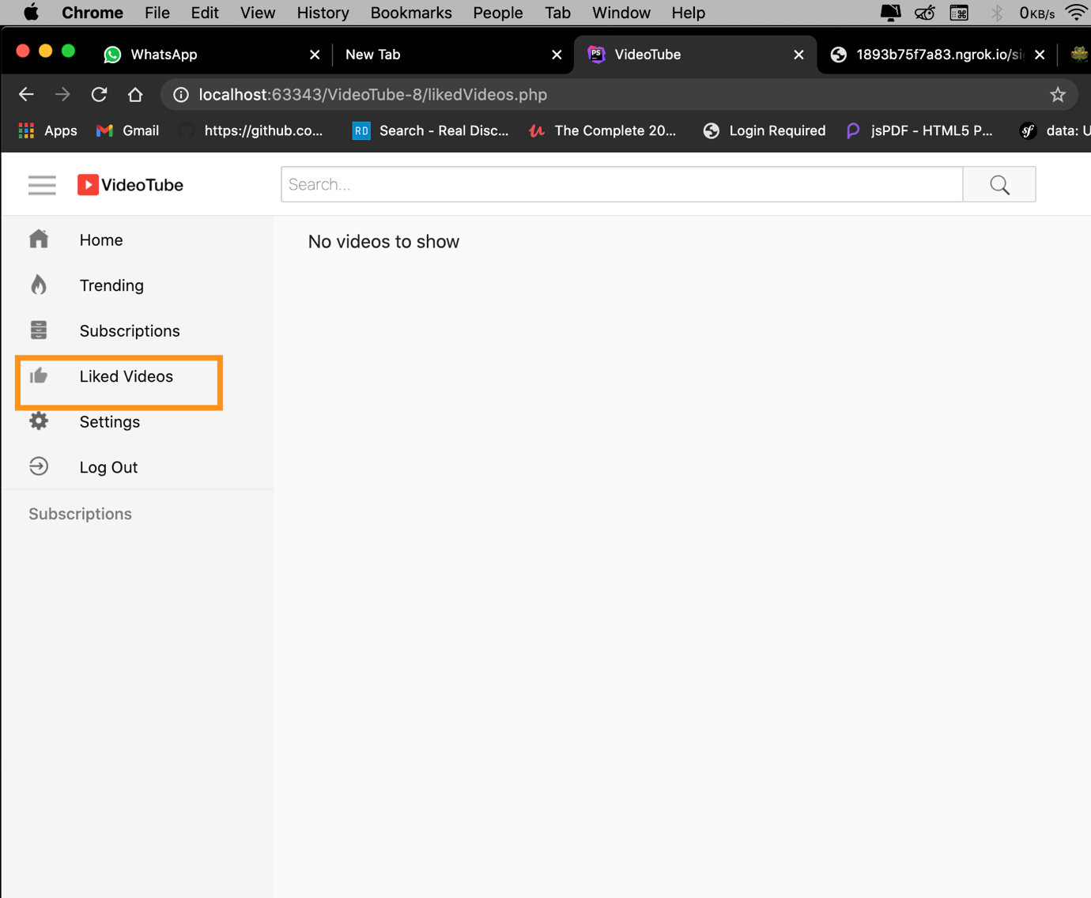

**Liked videos will be shown on this page**

All the liked videos by the user who are logged in will be shown on this page with the number of views and who uploaded it. Also date and time will be mentioned for the same.

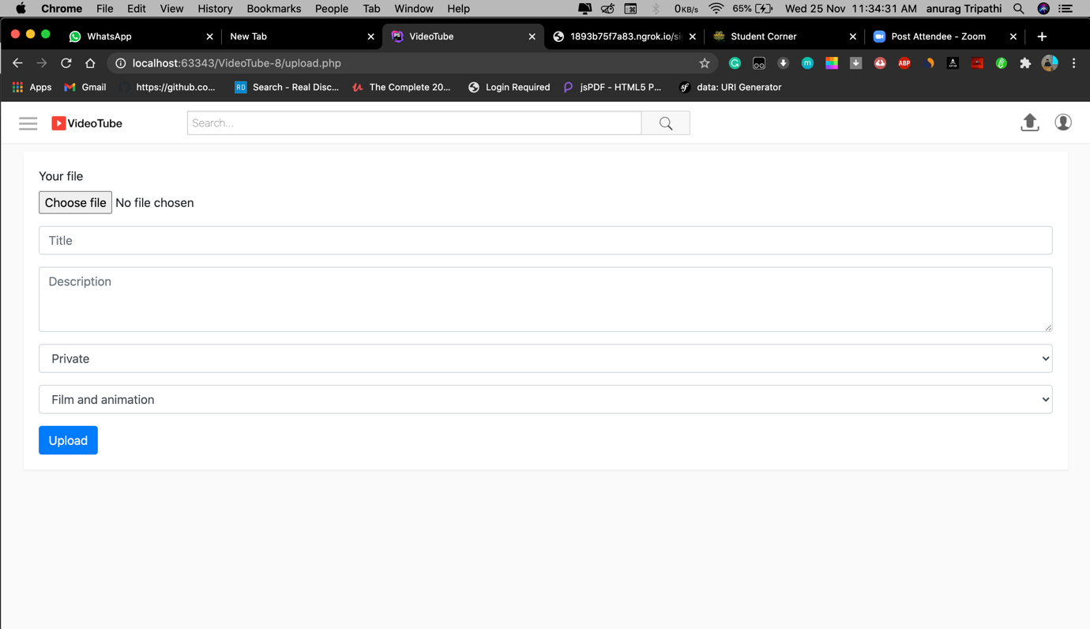

Upload page

User can upload video from here. User can

1) set title

2) write description

3) choose whether to keep videos private or public

4) user can choose what category does there video fall in.

5) upload videos

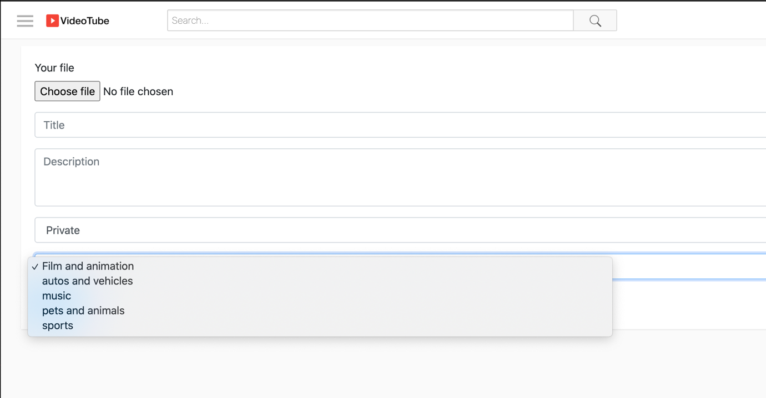

Categories

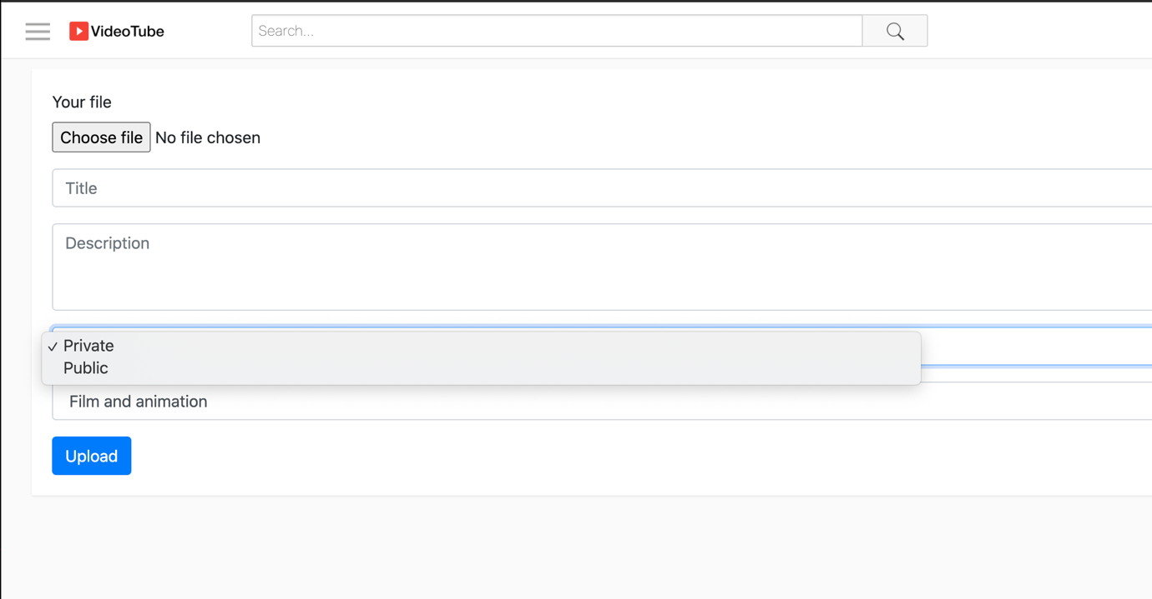

Categories

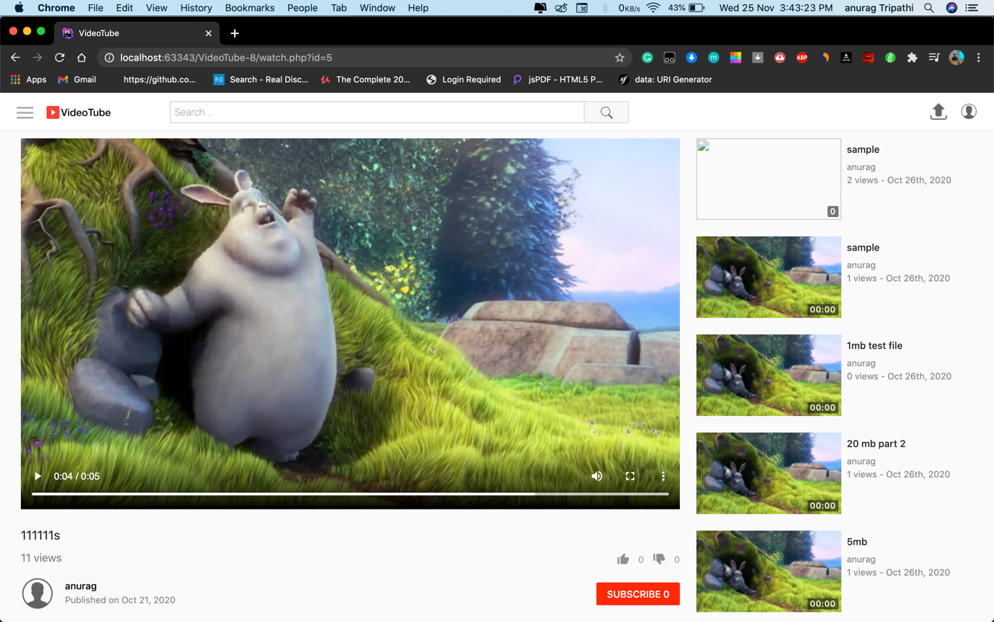

**Video interface for user**

User can like dislike video also he can subscribe to the content creator for personalised feed . User can watch it on full screen as well as PIP (picture in picture mode) on phones.

Video player has controls below mentioned:

1) playback

2) volume

3) full screen

4) more

**Extras**:

1) like

2) dislike

3) subscribe

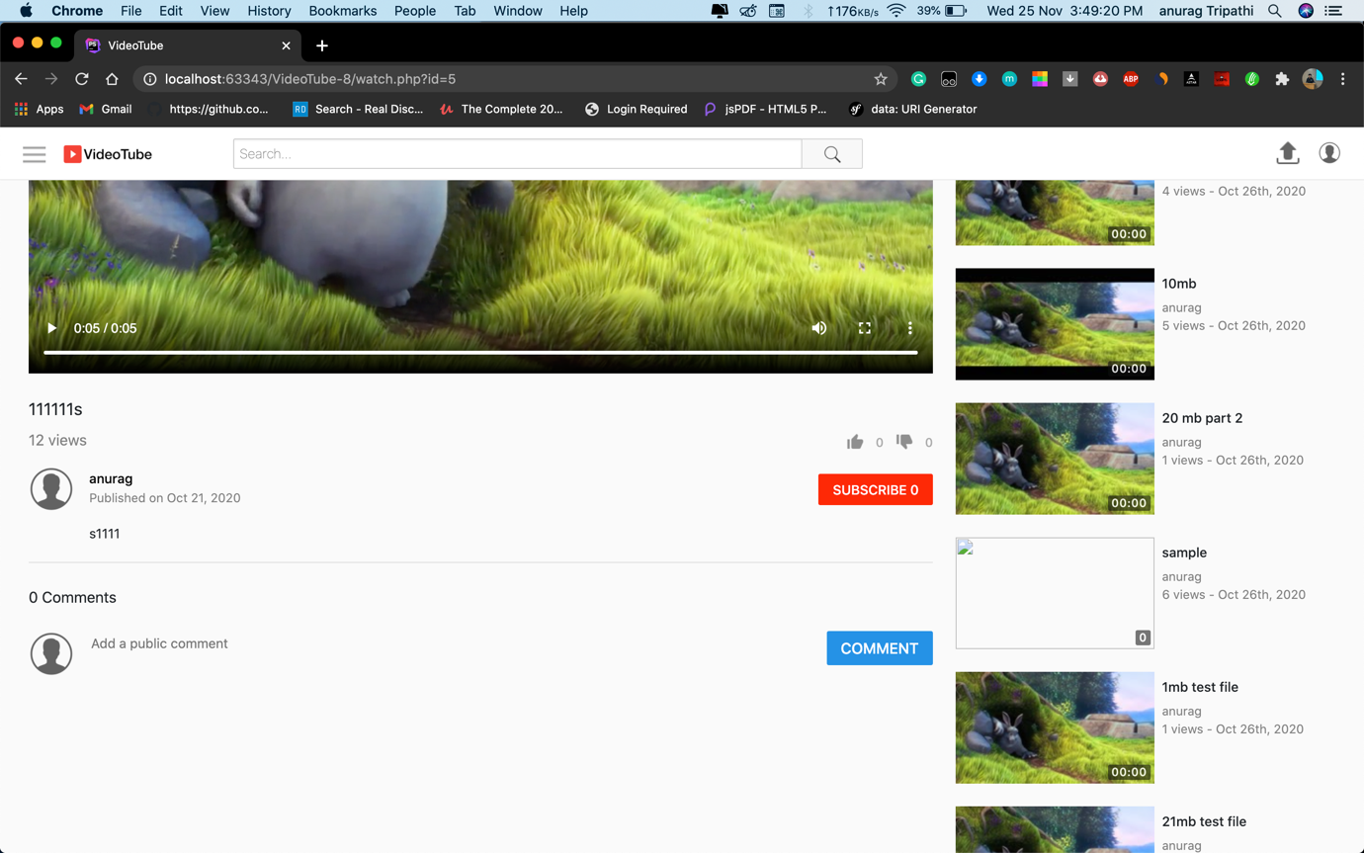

**description**

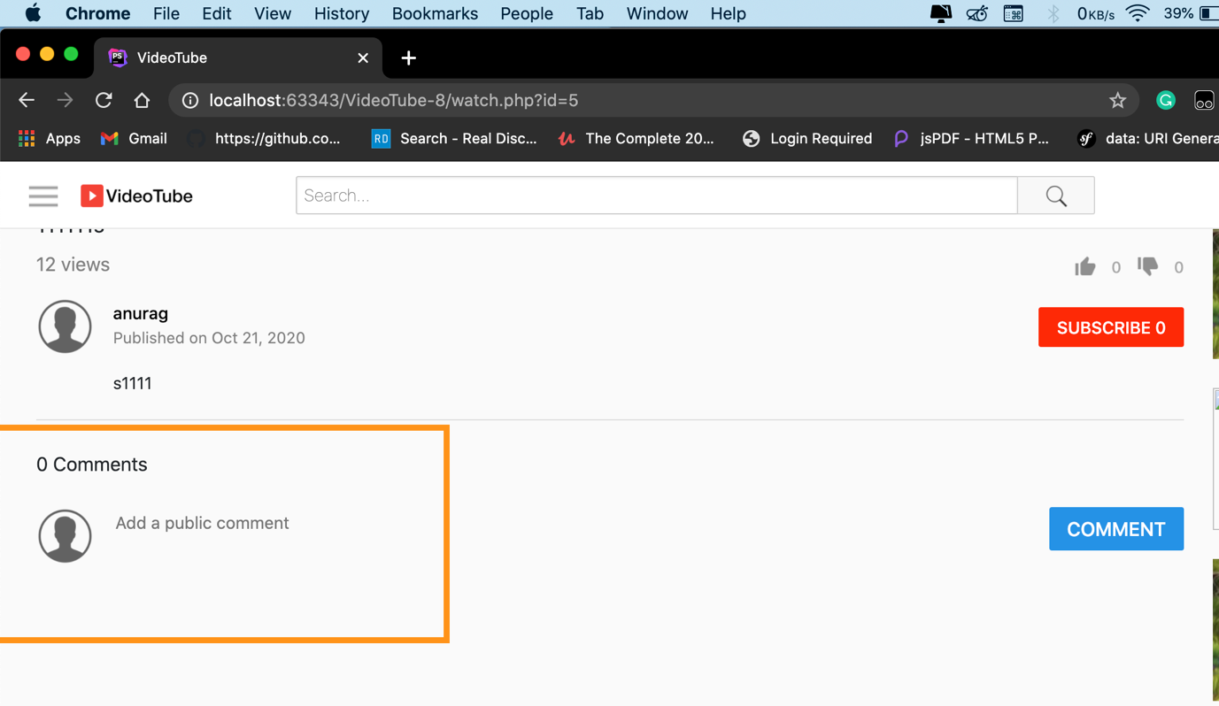

**Comment box**

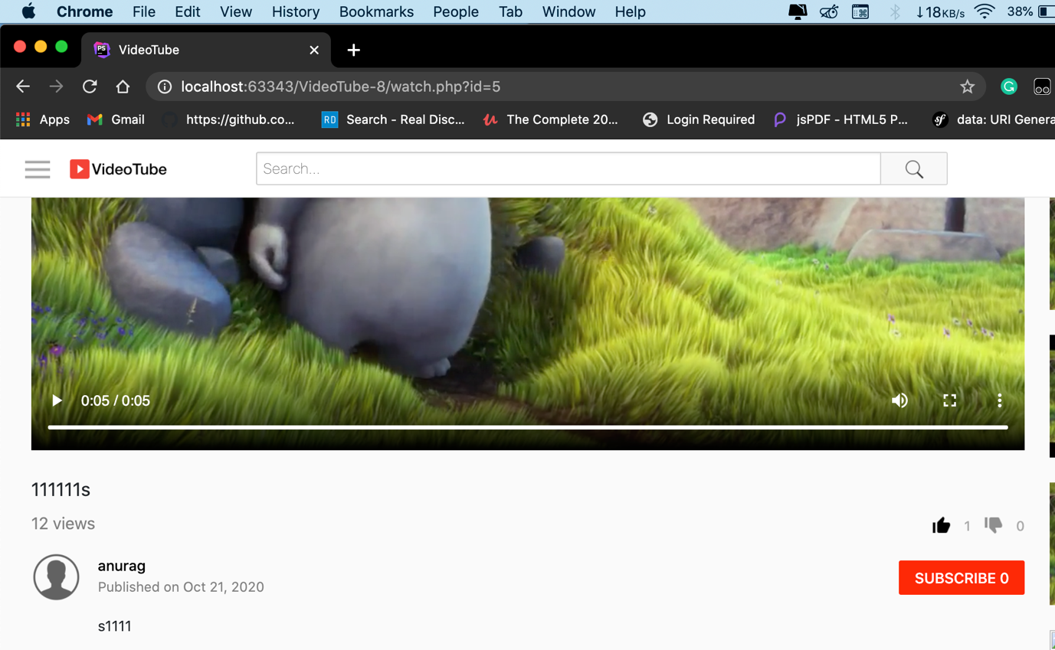

**Liked video**

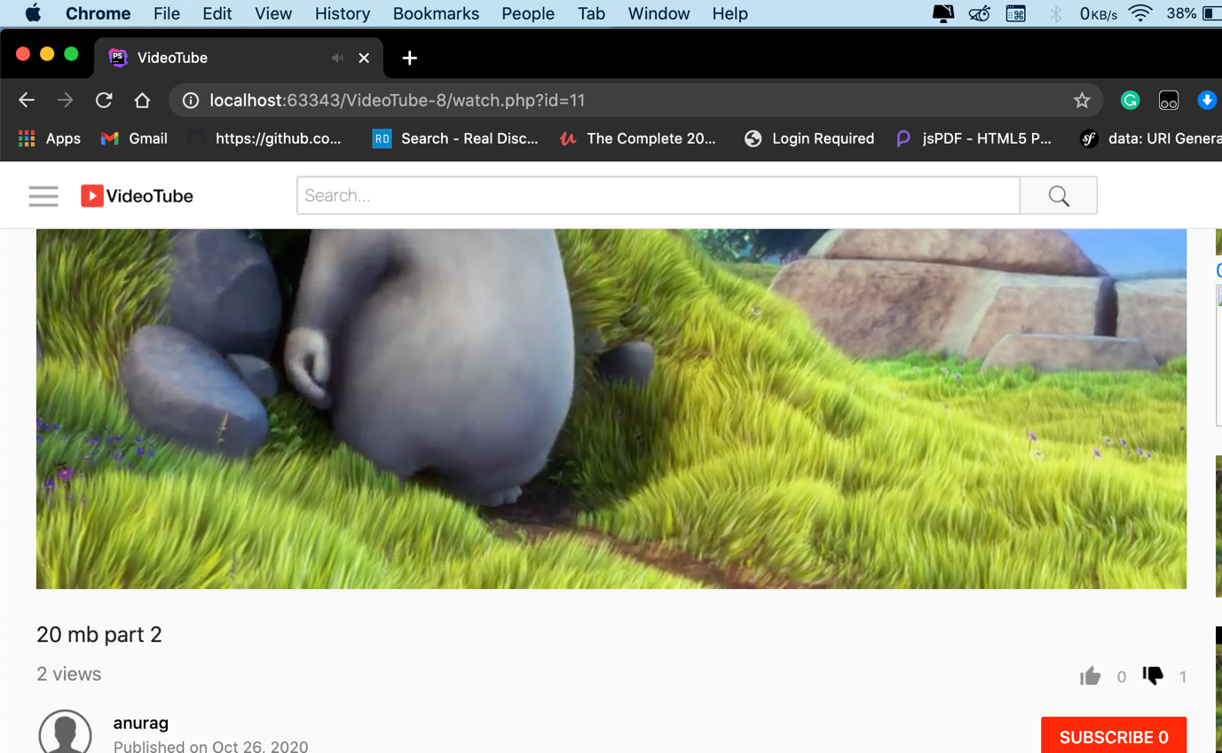

**Disliked video**

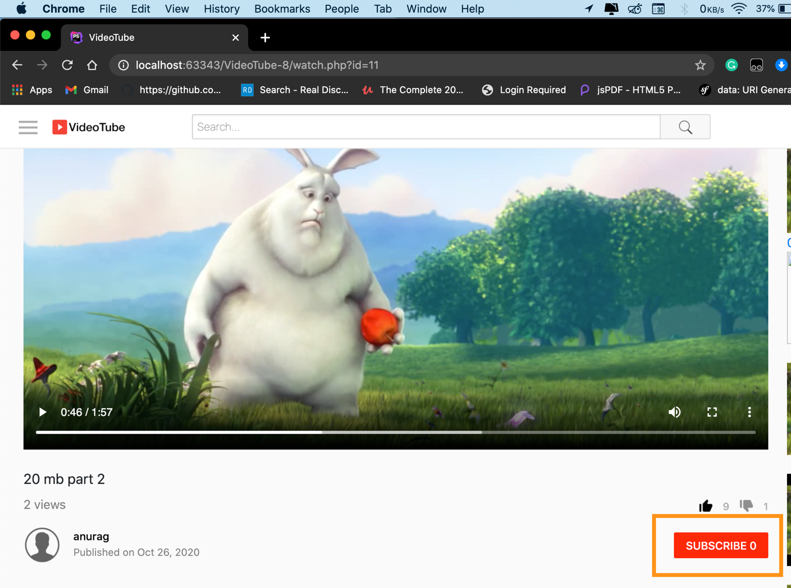

**Unsubscribed channel**

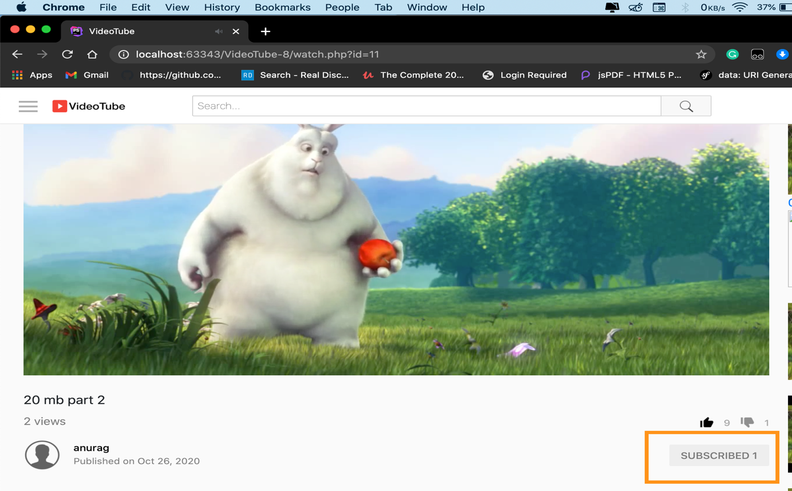

**Subscribed channel**

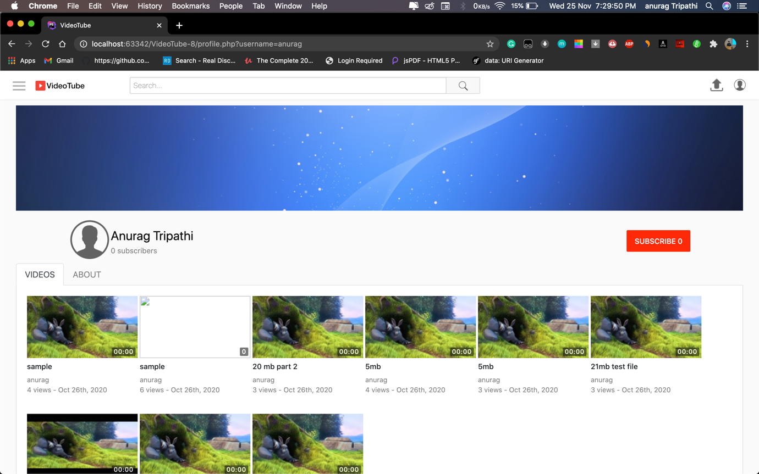

**Content creator page**

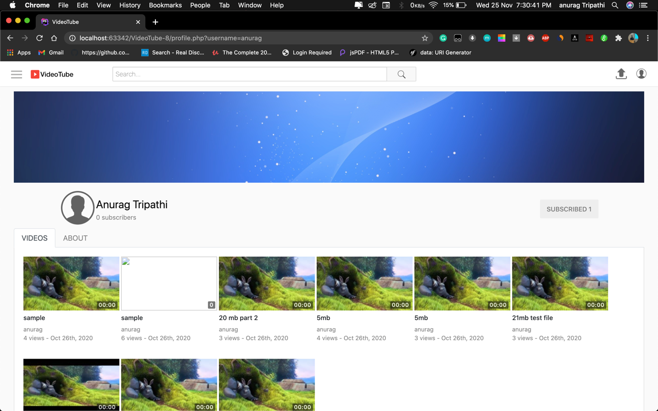

**Subscribed channel of creator by user**

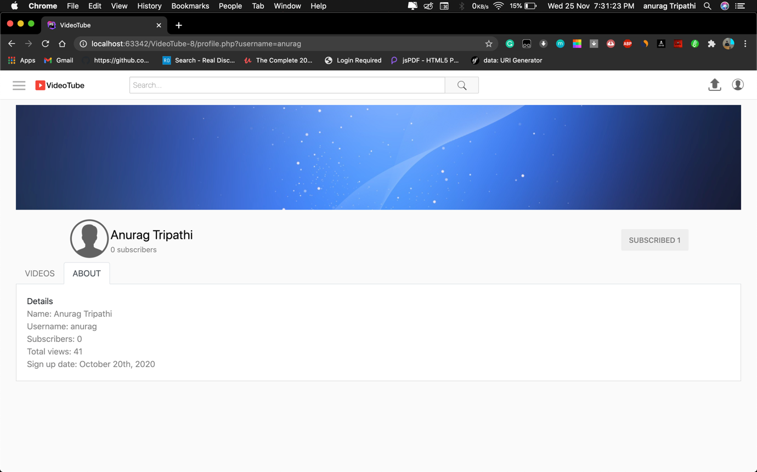

**About of the user’s**

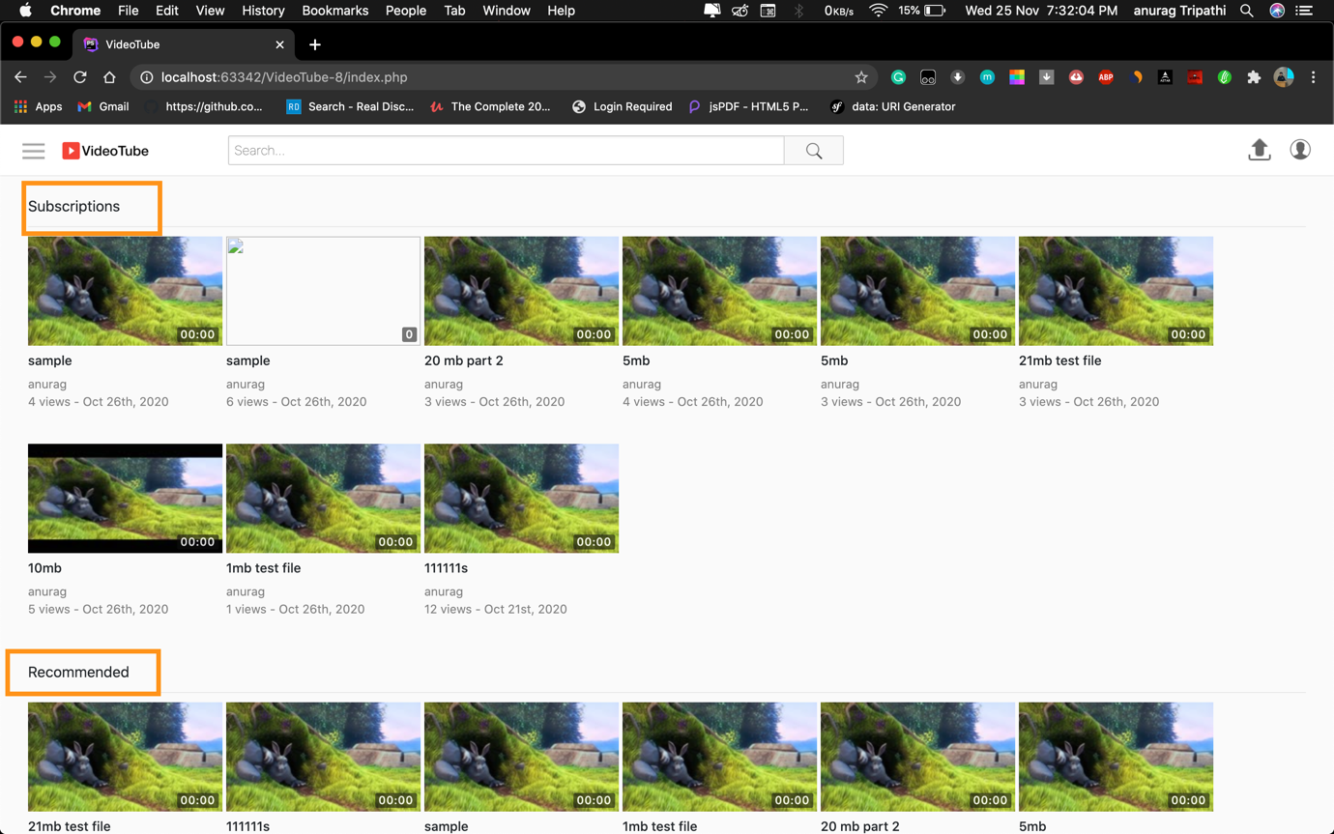

**Subscriptions for the user**

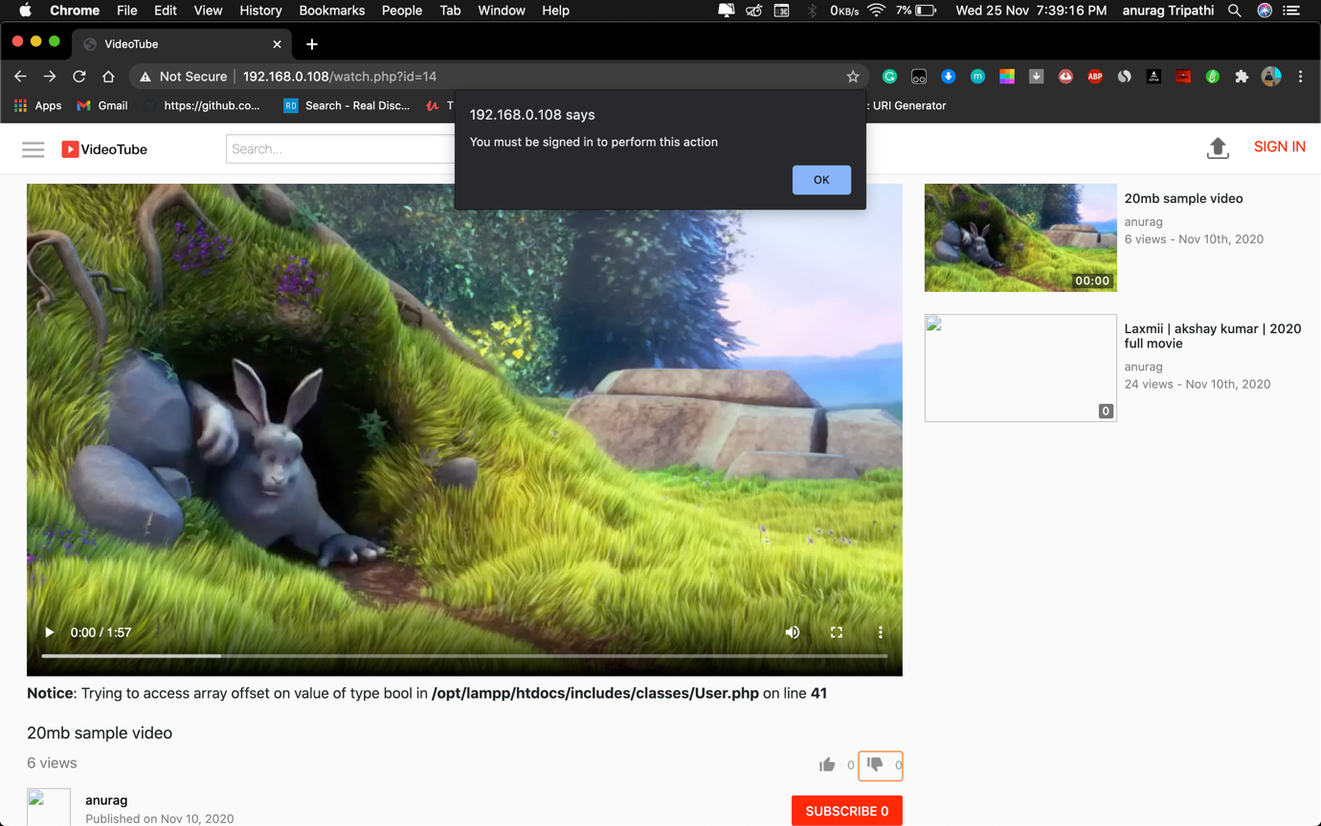

**WARNING**

Warning window will pop up by saying if any of the following action is performed without signed in :

1) liking videos

2) disliking

3) comment

4) liking comment

5) replying comment

6) subscribing to channel

7) uploading videos



**Subscription window**

Special option for the user’s who have subscribed to someone on the website a separate option will be shown on the top which will consist of videos of creators to which user has subscribed. Where as recommended section will remain same as normal.

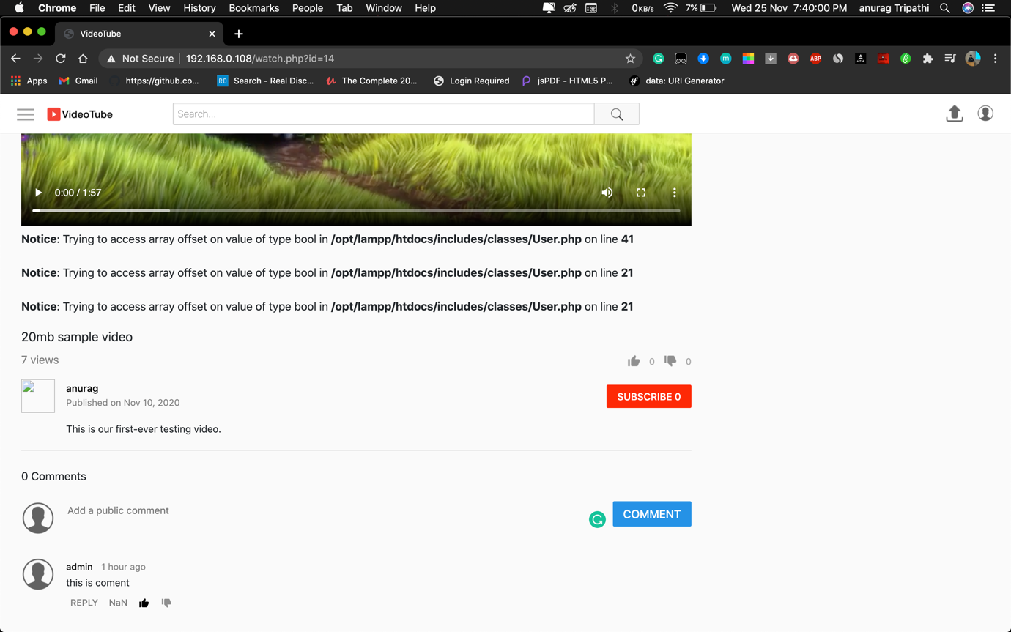

**Adding comment to videos**

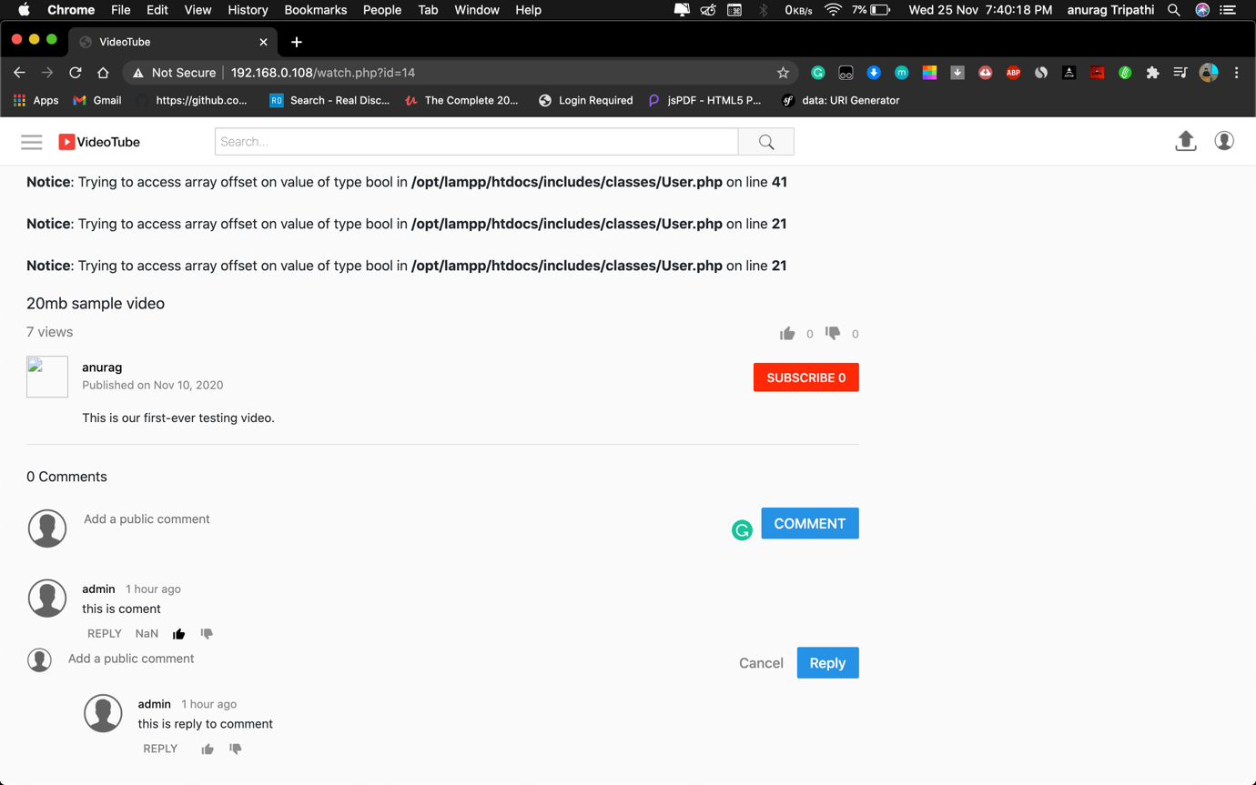

**Reply to comment**

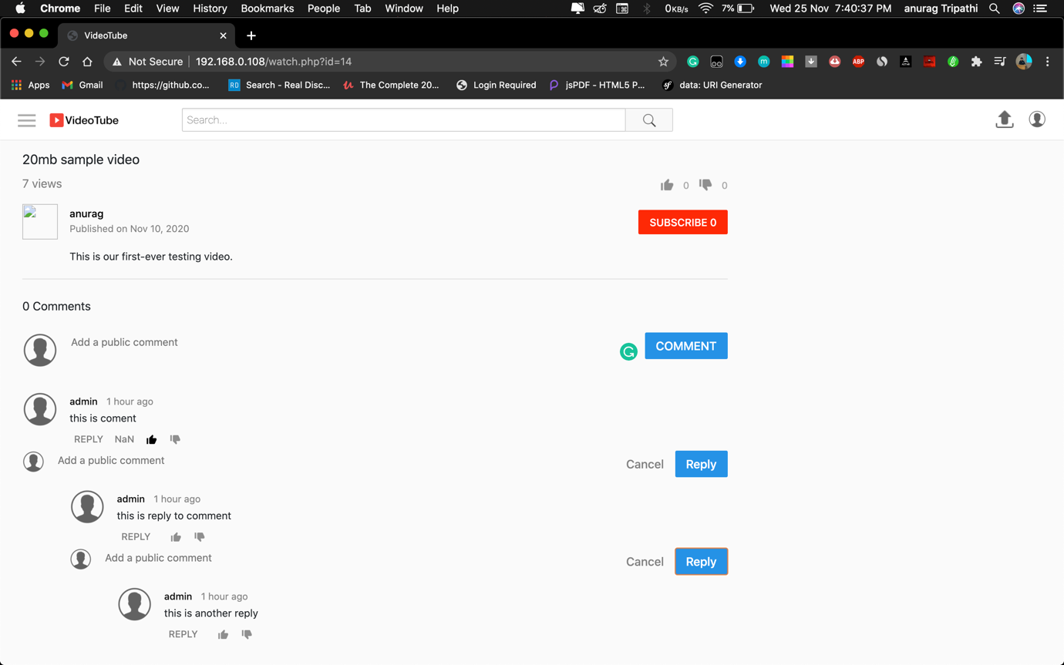

**More replies to comment**

On comment section user can write comment, like comment or dislike a comment also one can reply to a particular comment.

1) comment

2) like comment

3) dislike comment

4) reply to comments

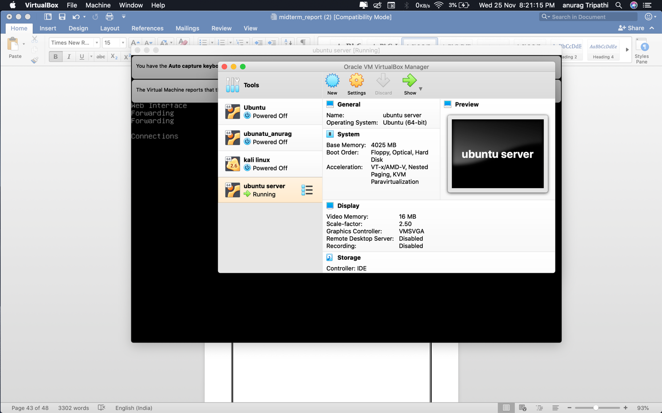

**Virtual machine for private server**

Using Virtual machine to create private server. In Vm ware I downloaded linux server and set it up in such a way that it suits best to our website.

Configuration:

Ram : 4gb

Storage: 60gb ssd

OS: ubuntu 64 bit

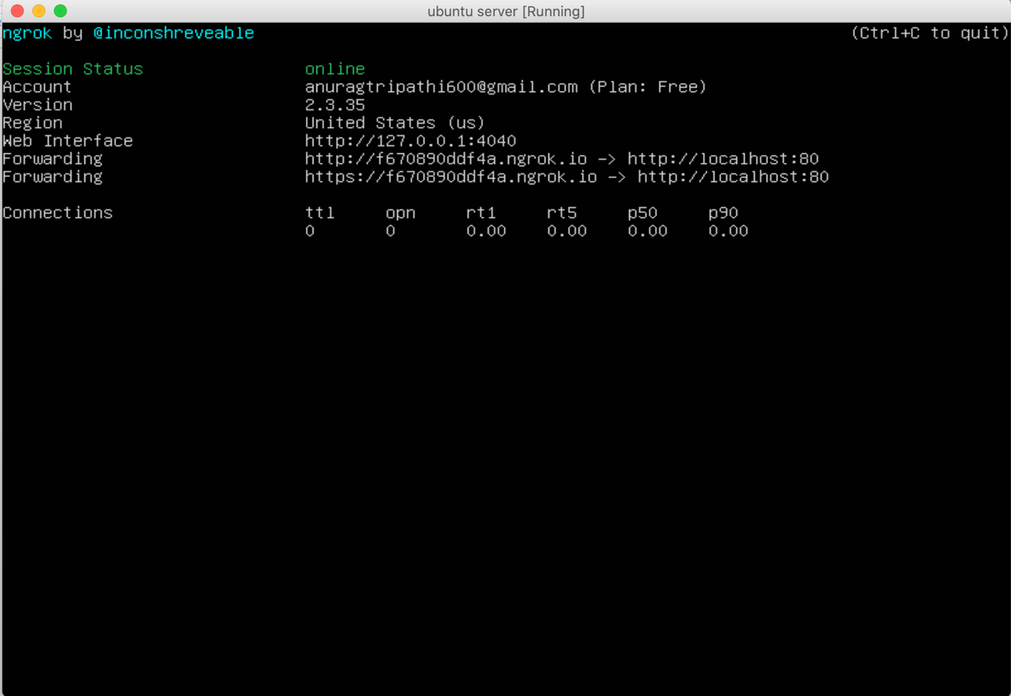

**Live server**

Live server using linux server and ngrok

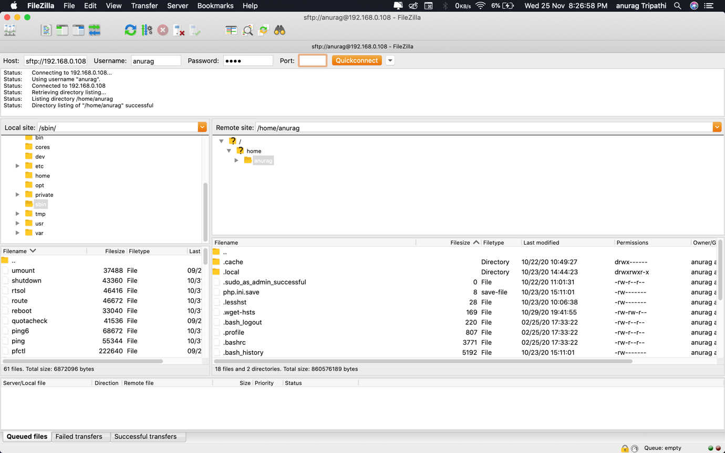

**Filezilla**

File zilla stores all files for the website and server fetches files from here live.

**TESTING**

Testing is a group of techniques to determine the correctness of the application under the predefined script but, testing cannot find all the defect of application. The main intent of testing is to detect failures of the application so that failures can be discovered and corrected. It does not demonstrate that a product functions properly under all conditions but only that it is not working in some specific conditions.

**Unit Testing**

Unit testing involves the testing of each unit or individual component of the software application. It is the first level of software testing. The aim behind unit testing is to validate unit component with its performance.  
A unit is a single testable part of a software system and tested during the development phase of the application software.

This testing aims to test the correctness of isolated code. A unit component is an individual function or code of the application. White box testing approach used for unit testing and usually done by the developers.

**Integrated Testing**

Integration testing is the second level of the software testing process comes after unit testing. In this testing, units or individual components of the software are tested in a group. The focus of the integration testing level is to expose defects at the time of interaction between integrated components or units.

Unit testing uses modules for testing purpose, and these modules are combined and tested in integration testing. The Software is developed with a number of software modules that are coded by different coders or programmers. The goal of integration testing is to check the correctness of communication among all the modules.

**CONCLUSION**

The project entitled Cinemax was completed successfully. The system has been developed with much care and free of errors and at the same time it is efficient and less time consuming. The purpose of this project was to develop a web application for enjoying videos. This project helped us in gaining valuable information and practical knowledge on several topics like designing web pages using html & css, usage of responsive templates and management of database using mysql. Also the project helped us understanding about the development phases of a project and software development life cycle. We learned how to test different features of a project. This project has given us great satisfaction in having designed an application which can be used to enjoy some great content. There is a scope for further development in our project to a great extend. A number of features can be added to this system in future like add to watch later and more.

**FUTURE SCOPE**

The website has many future scope further. We may add the location details of the videos. The second feature we can add is we make an watch later button. We can even add a share button which will help people to share content directly to there friends. We can further expand the project to and add many different features in it and vastly make it helpful.

**REFERENCE**

* [www.wikipedia.org/](http://www.wikipedia.org/)
* [www.udemy.com/](http://www.udemy.com/)
* [www.stackoverflow.com/](http://www.stackoverflow.com/)
* [www.google.com/](http://www.google.com/)